**ASSIGNMENT – 4**

|  |  |
| --- | --- |
| Student Name | Oviyashree.A |
| Register Number | 311419104061 |

**Question 1**:

Pull an image from docker hub and run it in docker play ground

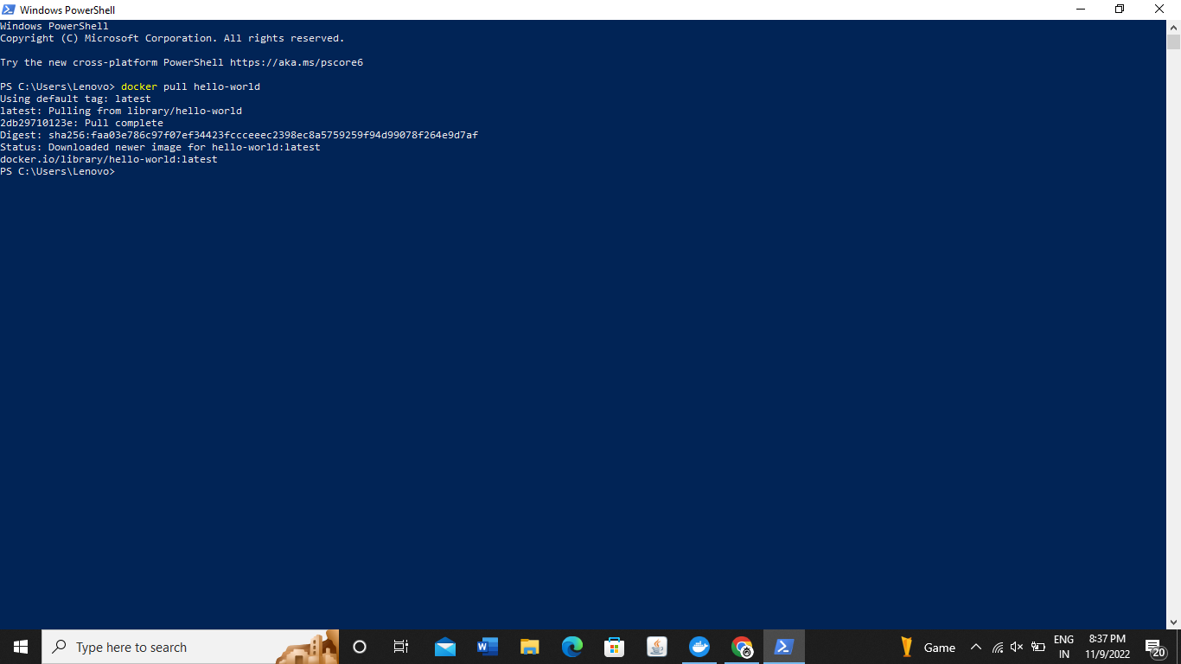

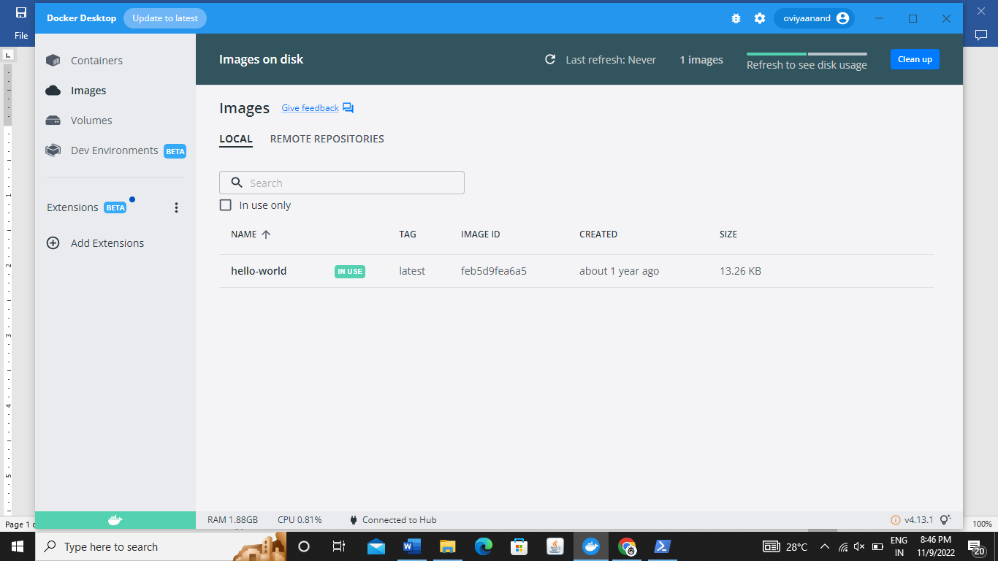

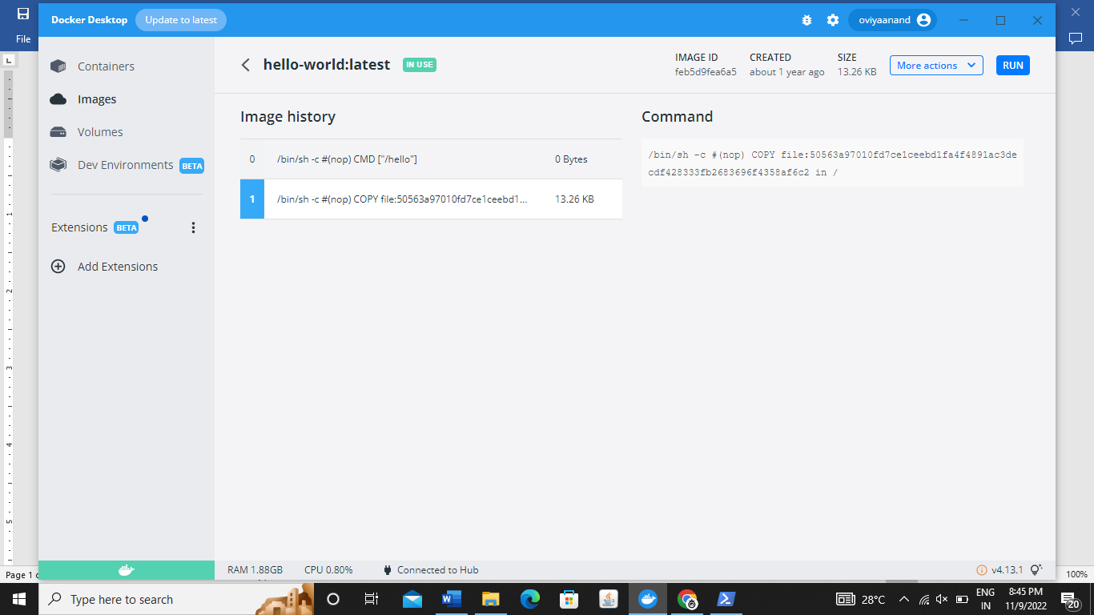

**Question – 2:**

Create a docker file for the job portal application and deploy it in Docker desktop application

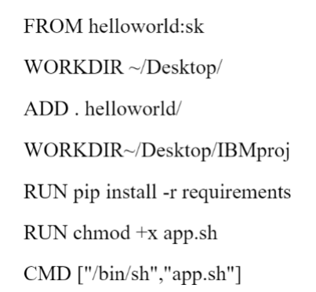

**Question 3:**

Create a IBM container registery and deploy helloworld app or job portal app.

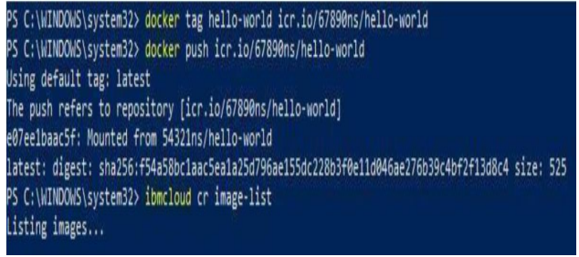

**Question 4:**

Create a kubernetes cluster in IBM cloud and deploy hello world images or job portal image and also expose the same app to run in node port.

